# Presenting Findings

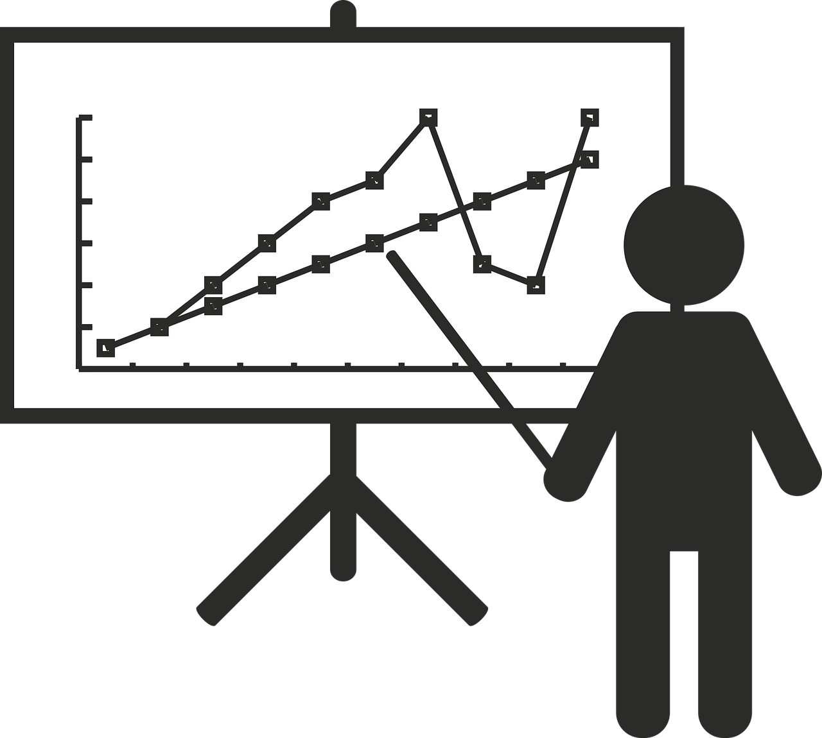

Being able to effectively present your findings is critical in the data science world. You can analyze and interpret data all day long, but if you are not able to explain and present what you have found, there will be little meaning or actionable outcomes due to your findings.

In this lesson, we will practice collecting, explaining, and presenting the important data and details of the mini-project.